Accelerated Math 7

Mrs. Feil

Name: __________________________________

Parent Signature: ______________________

🢭scale drawings 🢭introducing proportional relationships 🢭measuring circles 🢭proportional relationships 🢭exponents and scientific notation 🢭rational number arithmetic 🢭expressions, equations, and inequalities 🢭angles, triangles, and prisms 🢭probability, sampling, and variability in data sets 🢭rigid transformations and congruence 🢭dilations, similarity, and introducing slope 🢭linear relationships.

THINGS WE WILL LEARN

SUPPLIES NEEDED DAILY

* 3-ring binder
* notebook paper
* 1-subject spiral notebook
* pencils
* workbook *provided
* planner *provided
* homework folder

OTHER SUPPLIES (optional)

* highlighters
* colored pencils

Please refer to the Northern Middle School Grading policy.

Practice problems and interacting with notes each evening is expected. Students are graded on effort for homework.

HOMEWORK

GRADES

feilt@gcsnc.com

CONTACT ME

I will upload notes and supplementary materials into Canvas. Canvas can be accessed through NCEdCloud or gcs.instructure.com

I will update grades at least once per week. Parents should check PowerSchool regularly.

ACCESS AT HOME

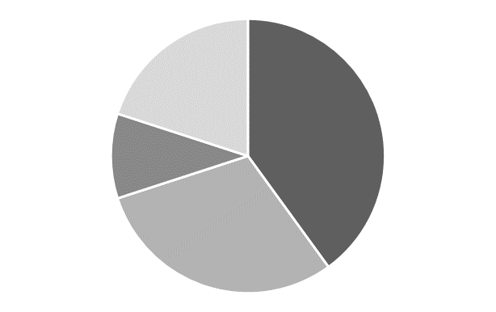

Tests 40%

Quizzes 30%

GRADING

Homework 10%

Classwork 20%

Tutoring opportunities will begin in October. More information will follow as we approach October.

TUTORING

Syllabus